JAVA DIGITAL ASSINGMENT 1

Name: Om Ashish Mishra

Registration Number: 16BCE0789

Slot: G2

The Question:

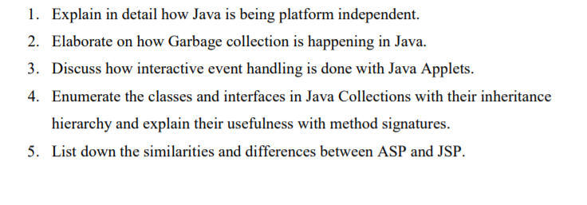

The Answer: